Maris Kilgus

Final Project

Dr. Wilson

14 Dec. 2022

Antibiotic Effects on Cow Greenhouse Emissions

Cows are well known for releasing greenhouse emissions in the atmosphere. Like any other well taken care of animal, cows need antibiotics like benzylpenicillin and tetracycline over their life. Some farmers use antibiotics for animal performance like more meat (DeVuyst 2017). This begs the question, how do antibiotics effect greenhouse emissions from cows?

Within the first three boxplots of gas fluxes CO2, CH4, and N2O, there is clear significance between the CO2 in the antibiotic treatments and control. Antibiotics increase the flux of CO2 in cow gas compared to the control without antibiotic treatment as seen in Figure 1. There is a p-value of 0.001044, which is below 0.05, proving significance. Thus, the null hypothesis is rejected. Although CH4 and N2O show no significance, they are not the main focus of the study since CO2 is the most prominent gas from cows. It is fortunate that in the analyses in this report, there is more carbon dioxide than methane, because methane is a potent greenhouse gas that is 20 times greater than CO2 (The Organic Center 2016). The effects of antibiotics are heavily being recognized by the scientific community. The effects are leading to ecosystem changes like uptake of nitrogen (Poppick 2019). Not only are antibiotics increasing greenhouse emissions, but they are taking up plant nutrients.

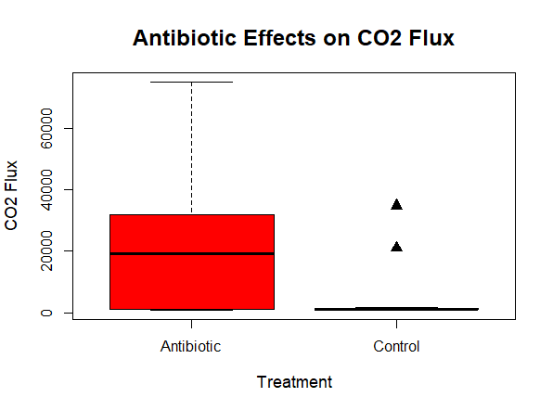

Figure 1: Treatment effects on the CO2 flux.

The CH4 p-value is 0.2268 and p-value of N2O is 0.3921. The gas flux of N2O is very minimal due to the small flux in the control, which makes N2O the perfect independent variable shown in Figure 2. A maximum of 5 for the N2O flux is extremely small compared to the 60,000 CO2 flux. Methane production prominence during antibiotic dosed cows is 80% higher than untreated cows (Perkins 2016). Therefore, it is a surprise of how much flux of methane there is over the other gases. The increase in methane is due to archaea microorganisms when treated with antibiotics.

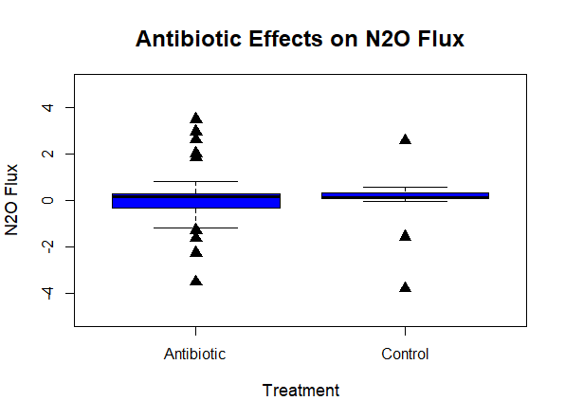

Figure 2: Treatment effects on the N2Oflux.

Using a scatterplot, there is a drastic increase of the flux of CO2 compared to N2O. Overall, the fluxes of CO2 and N2O have a positive linear regression in Figure 3. As the flux of N2O increases, the flux of CO2 also increases. It can easily display how minor N2O increases can drastically increase CO2 by roughly 5,000 CO2 flux for every 0.5 N2O flux increased. Additionally, the t-value of the intercept between the fluxes of CO2 and N2O is 6.782, whereas the independent flux N2O is -0.310. This proves how the size difference varies greatly within the data from the two experiments.

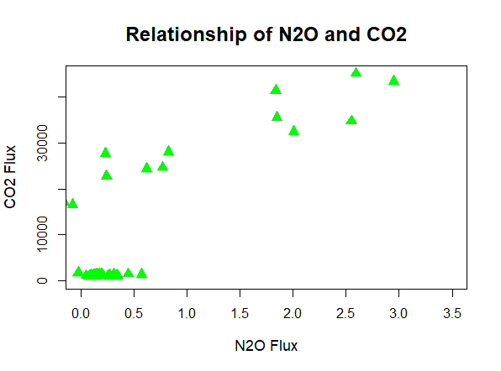

Figure 3: Relationship between the N2O and CO2 fluxes.

In conclusion, using the N2O and CO2 fluxes prove the effect antibiotics have on greenhouse gases in cows. When cows have antibiotics, the greenhouse gases increase. About 73% of all antibiotics worldwide, are used for farm animals (Compassion in World Farming). For the mass number of animals using antibiotics, there needs to be legislation permitting unauthorized usage of antibiotics. It is clearly leading to an increase on greenhouse emissions, which contributes to global climate change even if it is only 4% greenhouse gas emission (Perkins 2016). Every little bit less of gas emission helps the planet.

Citations:

Compassion in World Farming, Alliance to Save Our Antibiotics, Our Campaigns, <https://www.ciwf.org.uk/our-campaigns/antibiotics-health-crisis/?gclid=EAIaIQobChMIhrH29eP4-wIVBPnICh1CMQvMEAAYASAAEgIKsPD_BwE>

Danielsson, Rebecca et al. (2019), Data from: Compound- and context-dependent effects of antibiotics on greenhouse gas emissions from livestock, Dryad, Dataset, <https://doi.org/10.5061/dryad.t7f3rc8>

DeVuyst, Cheryl and Devuyst, Eric. (2017), What Consumers Need to Know About the Use of Antibiotics in Food Animal Production, Oklahoma State University, Extension, <https://extension.okstate.edu/fact-sheets/what-consumers-need-to-know-about-the-use-of-antibiotics-in-food-animal-production.html>

Hammer, Tobin J. et al. (2016), Data from: Treating cattle with antibiotics affects greenhouse gas emissions, and microbiota in dung and dung beetles, Dryad, Dataset, <https://doi.org/10.5061/dryad.6bs01>

Perkins, Sid. (2016), Antibiotics May Give Cows Gas, Contribute to Climate Change, Science, Climate, <https://www.science.org/content/article/antibiotics-may-give-cows-gas-contribute-climate-change>

Poppick, L. (2019), Manure happens: The environmental toll of livestock antibiotics, Eos, 100, <https://doi.org/10.1029/2019EO136378>. Published on 08 November 2019.

The Organic Center (2016), Antibiotic Use in livestock Increases Methane Emissions From Cows, Research, <https://www.organic-center.org/research/antibiotic-use-livestock-increases-methane-emissions-cows>